LAB ACTION PLAN FOR WEEK 6
23BD1A663X

How to Run It
To run a multi-container setup like the one above:
- Save the file as docker-compose.yml.
Or
docker-compose.yaml
- To Start the compose

docker-compose up –d
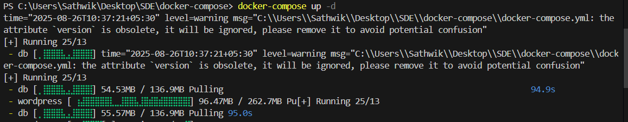
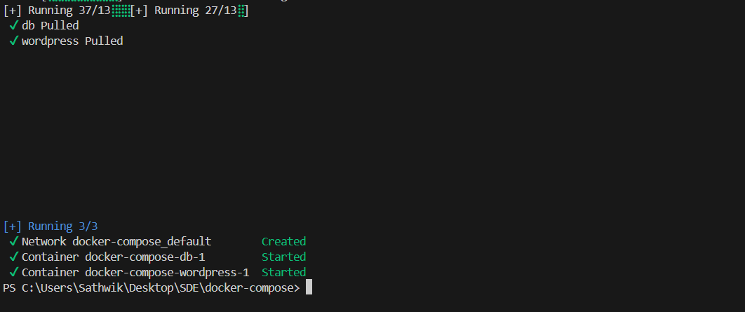


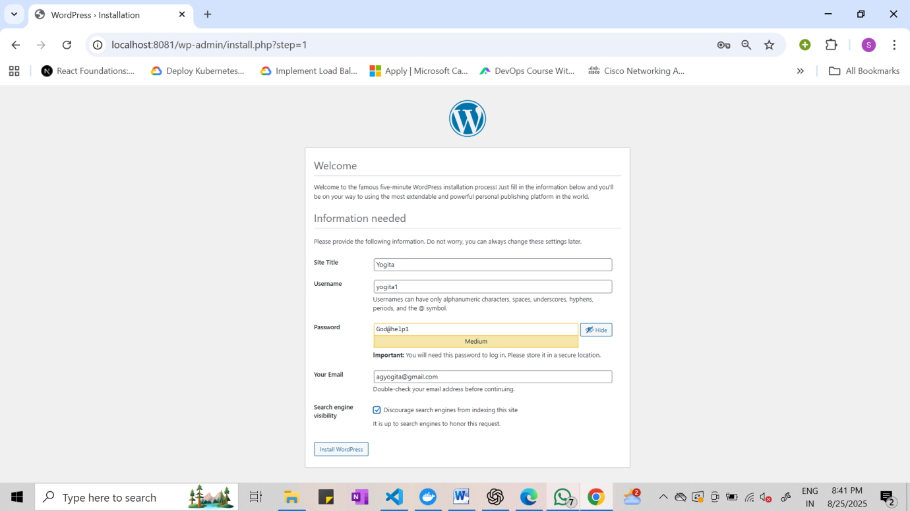
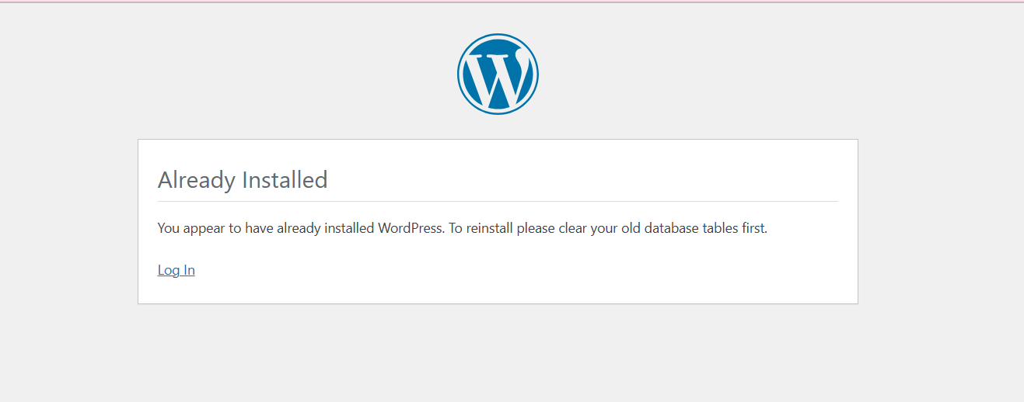

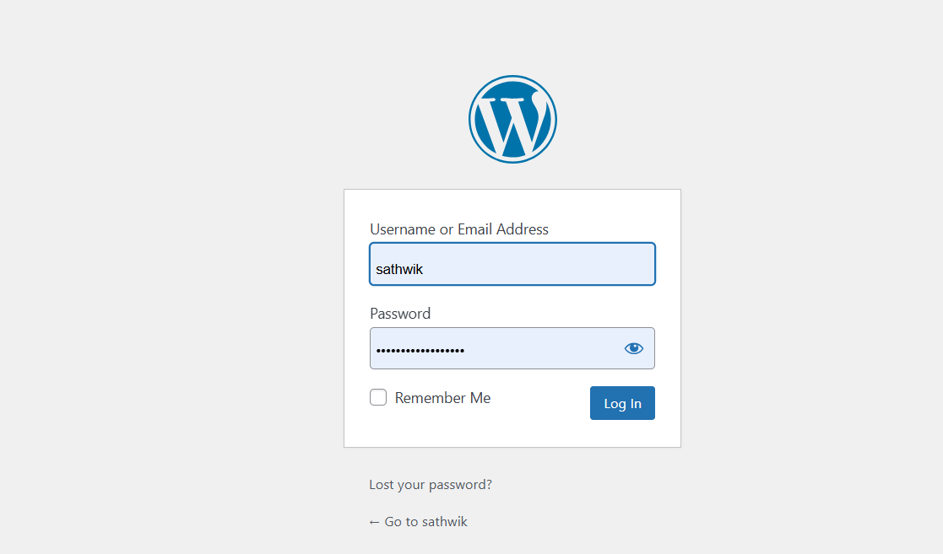

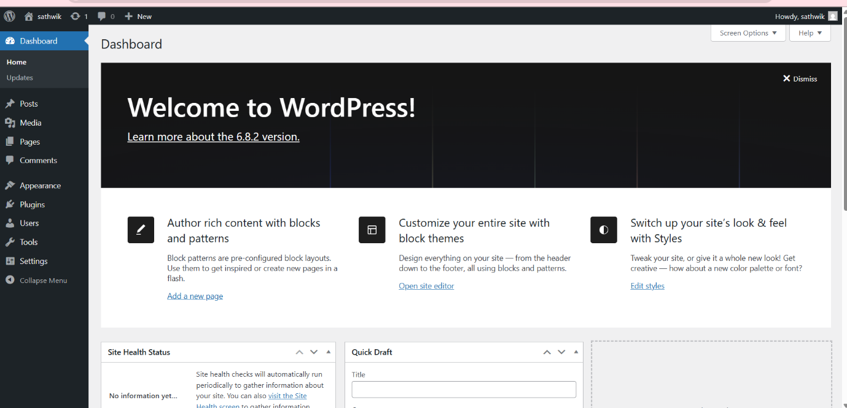

- To stop the containers
docker-compose down
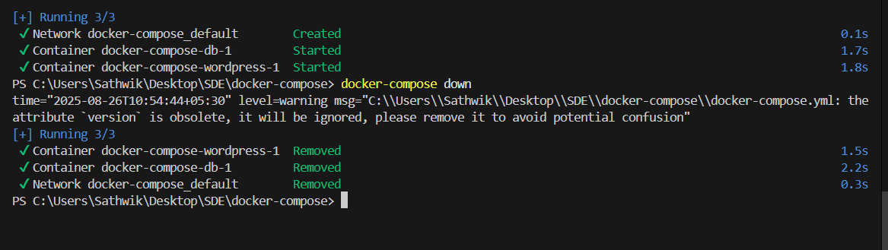

- To scale the container

docker-compose up --scale <service name>=2 -d

1.Define and run multiple interdependent services

Task:
- Create a new folder compose-lab
Inside it, create a file docker-compose.yml with the following content:

version: "3.9"
services:
web:
image: nginx:latest
ports:
- "8080:80"

db:
image: postgres:15
environment:
POSTGRES_USER: demo
POSTGRES_PASSWORD: demo
POSTGRES_DB: demo_db

II. Run the setup:

docker compose up -d
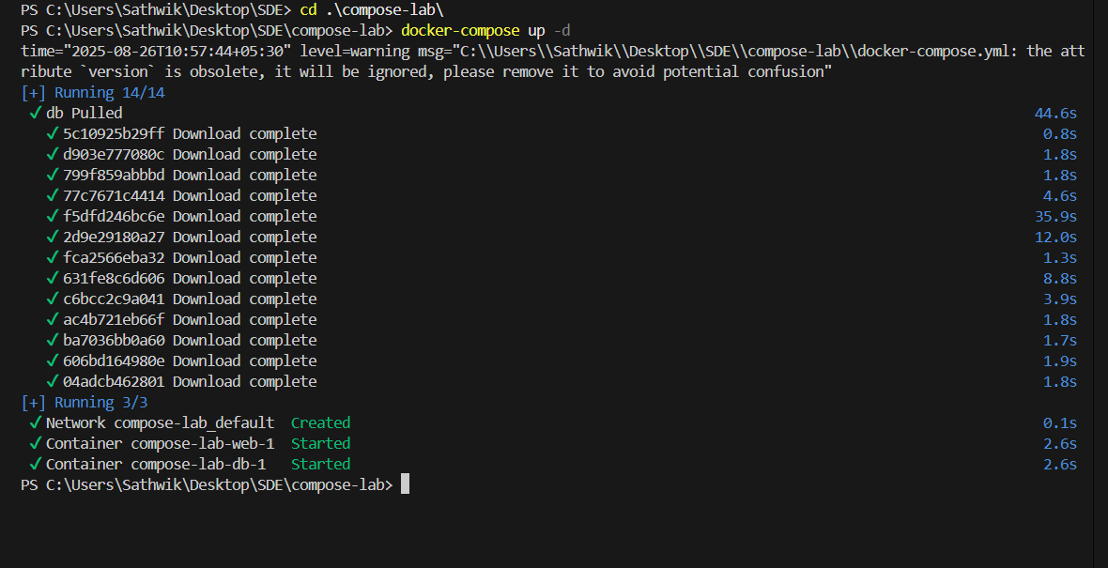

III. Open your browser and visit: http://localhost:8080.

IV. Expected Output:

Nginx welcome page is displayed.
db container runs in the background.


2.Write and interpret docker-compose.yml files
Task:
- Modify docker-compose.yml to add a Redis cache:

redis:
image: redis:alpine

II. Add a depends_on so web waits for Redis:
web:
image: nginx:latest
ports:
- "8080:80"
depends_on:
- redis

III. Restart the setup:
docker compose up -d
docker compose ps

IV. Expected Output:

Three services (web, db, redis) are listed as running.
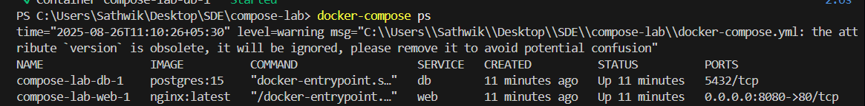

3.Deploy across different machines
Task:
- Zip your compose-lab folder.

Transfer it to another machine with Docker Compose installed.

II. Run:
docker compose up -d

Check that Nginx and Postgres work there as well.

III. Expected Output:
The same services run on the new machine without changes.
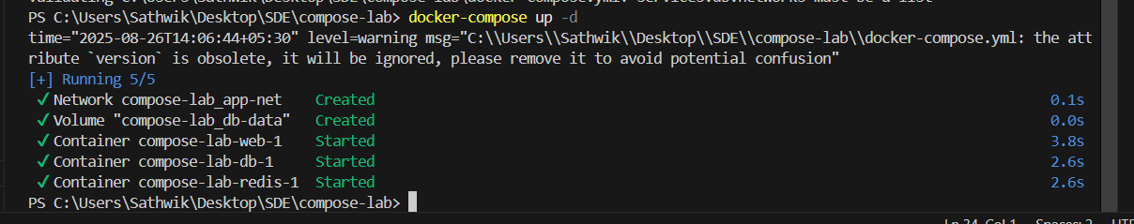

4.Networking and persistent storage
Task:
- Update your docker-compose.yml to add a custom network and volume:

networks:
app-net:

volumes:
db-data:

services:
web:
image: nginx:latest
ports:
- "8080:80"
networks:
- app-net
depends_on:
- db

db:
image: postgres:15
environment:
POSTGRES_USER: demo
POSTGRES_PASSWORD: demo
POSTGRES_DB: demo_db
volumes:
- db-data:/var/lib/postgresql/data
networks:
- app-net

II. Run:
docker compose up –d
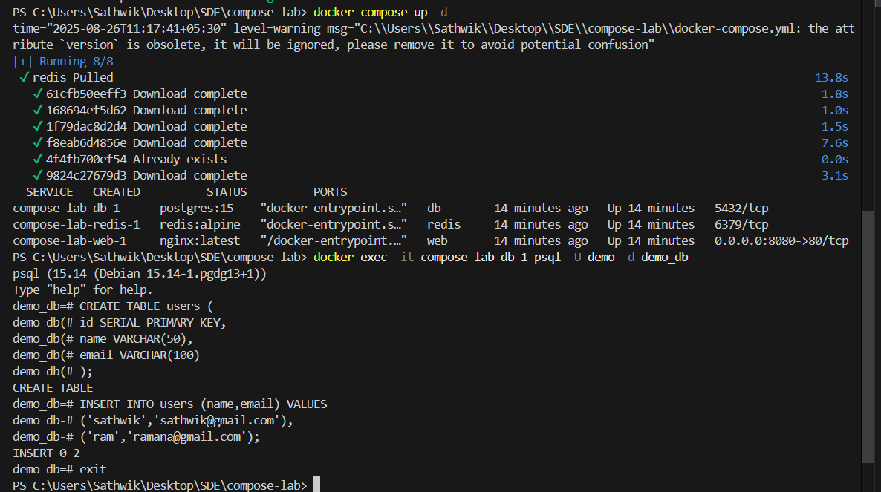

III. Insert some data into Postgres (optional with psql).
IV. Remove containers:
docker compose down
V. Start again:
docker compose up -d
VI. Expected Output:
Database data persists across restarts.
Services communicate via the app-net network using service names.
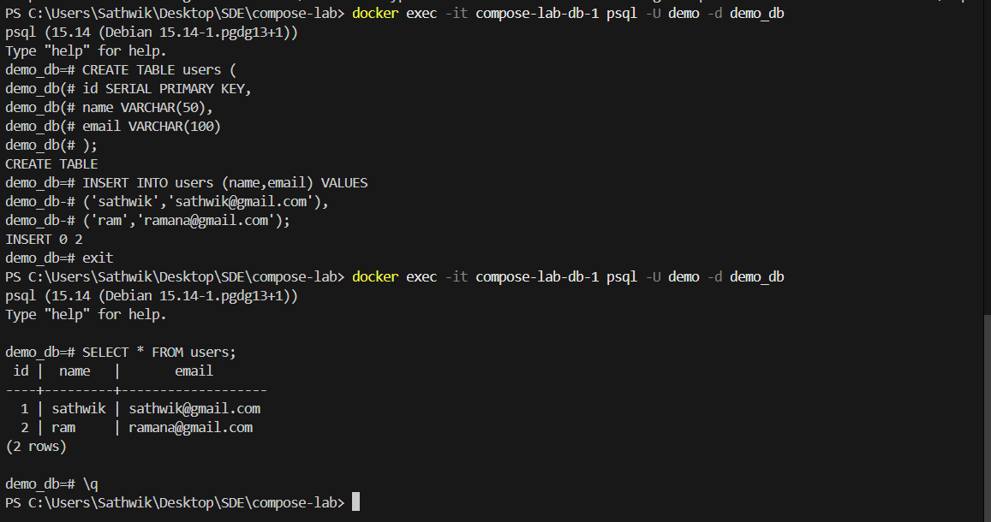

5.Faster iteration during development
Task:
- Create a simple Flask app in app.py:

from flask import Flask
app = Flask(__name__)
@app.route("/")
def home():
return "Hello from Flask + Docker!"
if __name__ == "__main__":
app.run(host="0.0.0.0", port=5000)

II. Add a Dockerfile in the same folder:

FROM python:3.10-slim
WORKDIR /app
COPY app.py /app/
RUN pip install flask
CMD ["python", "app.py"]
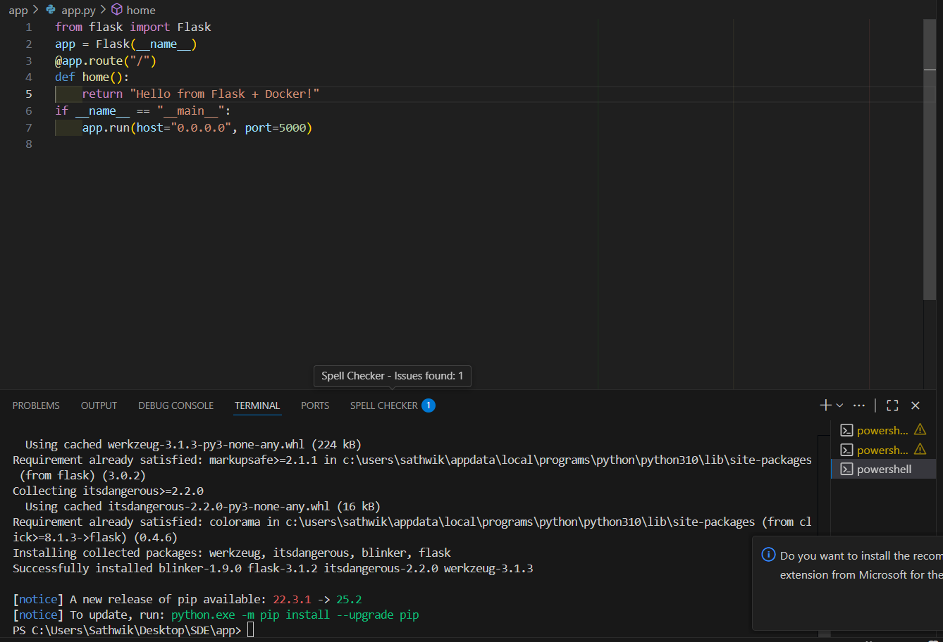

III. Update docker-compose.yml:
web:
build: .
ports:
- "5000:5000"
depends_on:
- db
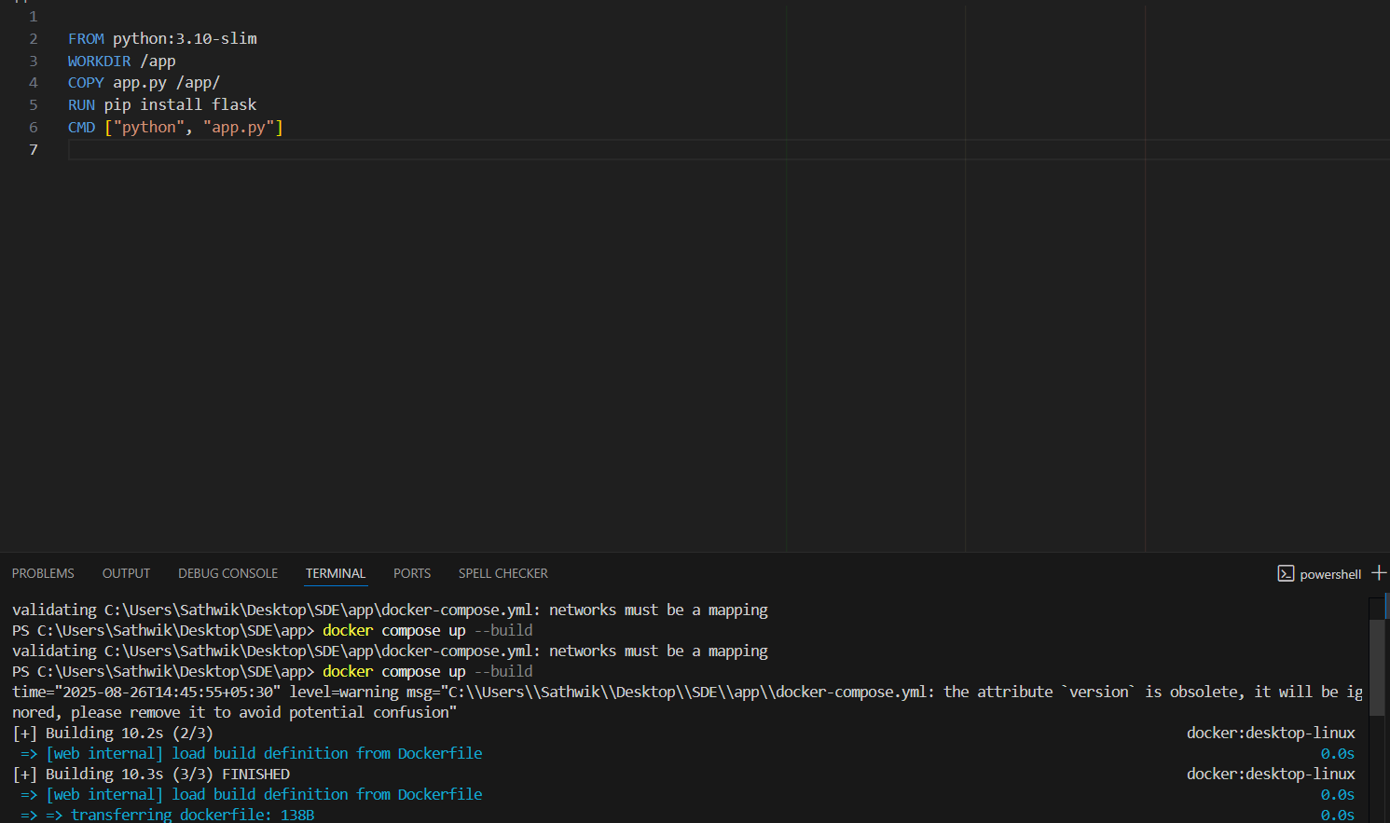

IV. Run:
docker compose up --build
Visit http://localhost:5000.
Change the return text in app.py (e.g., "Hello Docker Compose!").
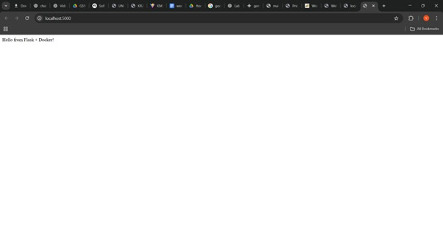

V. Rebuild:
docker compose up --build
VI. Expected Output:
New message appears instantly after rebuild.
